Web integration: embed Sense charts or data inside your own website

Table of Contents

* Introduction
* IFrame: Easy integration of App, sheet or charts
* Create mashups (1 HTML page which contains both OEM partner content and Sense content)
  + Creating mashups with the Mashup editor (DIV tag integration)
  + Creating mashups with the Visualization API
  + Qlik Visuals
  + Qlik Analytics for Visual Studio plug-in
  + Mashup Examples
* Extensions: the ability to create your own visualizations (charts, custom JS objects) inside an app
* Use Sense as a fast in memory database: Show Sense data/raw JSON objects in your own webserver
* Appendix A: Summary of the javascript div tag integration approach

Introduction

|  |  |
| --- | --- |
| There are 5 ways to integrate Qlik Sense into your website, our [development hub](https://www.youtube.com/watch?v=hjFlpj7uLl4) or the [Visual Studio plugin](http://help.qlik.com/en-US/sense-developer/2.2/Subsystems/Plugins/Content/GettingStarted/GettingStarted.htm) helps you will even generate the code for you! So most of the time you have to select or drag and drop to create an integrated web page. | Machine generated alternative text: •&hy in  • HTLL fw  Extend  • chyts w hic* A r -Z  Data only  tin t. y |

|  |  |  |  |
| --- | --- | --- | --- |
| Approach | Complexity | Template | Result |
| [Iframe](http://www.w3schools.com/html/html_iframe.asp) via [app integration API](https://help.qlik.com/en-US/sense-developer/2.2/Subsystems/APIs/Content/AppIntegrationAPI/app-integration-api.htm) and single configurator - paste Sense URL in Iframe on your site. | Very Simple, but ensure you know how to authenticate the user. | * + [Integrating app](https://help.qlik.com/en-US/sense-developer/2.2/Subsystems/Mashups/Content/AppIntegrationAPI/app-integration-api-examples.htm#anchor-1)   + [Integrating sheet](https://help.qlik.com/en-US/sense-developer/2.2/Subsystems/Mashups/Content/AppIntegrationAPI/app-integration-api-examples.htm#anchor-2)   + [Integrating app with bookmark](https://help.qlik.com/en-US/sense-developer/2.2/Subsystems/Mashups/Content/AppIntegrationAPI/app-integration-api-examples.htm#anchor-3)   + [Integrating app with single selection](https://help.qlik.com/en-US/sense-developer/2.2/Subsystems/Mashups/Content/AppIntegrationAPI/app-integration-api-examples.htm#anchor-4)   + [Integrating app with numeric value selections](https://help.qlik.com/en-US/sense-developer/2.2/Subsystems/Mashups/Content/AppIntegrationAPI/app-integration-api-examples.htm#anchor-5)   + [Integrating app with multiple selections](https://help.qlik.com/en-US/sense-developer/2.2/Subsystems/Mashups/Content/AppIntegrationAPI/app-integration-api-examples.htm#anchor-6)      * + [Integration of a single object](https://help.qlik.com/en-US/sense-developer/2.2/Subsystems/Mashups/Content/SingleIntegration/work-with-single-integration.htm)   + See the [Single configurator](http://localhost:4848/single) in de dev-hub (ensure Qlik Sense runs) | A Complete Sense hub, or dashboard or sheet or individual object.    The App Integration API provides parameters that can be used to create an URL that returns a complete HTML page containing the embedded app. This URL can be embedded in a web page, for example by including it in an iframe.  It allows you to pass parameters to an app and to open an app with one or several selections applied. |
| [Mashup editor](http://help.qlik.com/en-US/sense-developer/2.2/Subsystems/Mashups/Content/Howtos/working-with-mashups.htm) - DIV tags and javascript | Javascript knowledge needed | <http://localhost:4848/dev-hub/mashup-editor> | 1 complete integrated webpage using a div for each chart or sheet. You can pass context via REST or javascript API's |
| [Visual web component](http://help.qlik.com/en-US/sense-developer/2.2/Subsystems/Mashups/Content/QlikVisual/qlik-visual-web-component.htm) - only HTML tags | HTML knowledge needed | [Examples](http://help.qlik.com/en-US/sense-developer/2.2/Subsystems/Mashups/Content/QlikVisual/mashups-create-visualizations-on-the-fly.htm) | 1 html page (of the OEM partner), which includes sense charts by using simple HTML tags:  <qlik-visual appid="Helpdesk Management.qvf" type="barchart" cols='["Case Owner Group","=Avg([Case Duration Time])"]' options='{"title" : "On the fly barchart"}' >  </qlik-visual> |
| [Vizualizations on the fly](http://help.qlik.com/en-US/sense-developer/2.2/Subsystems/Mashups/Content/Howtos/create-visualization-on-the-fly.htm) | Javascript knowledge needed | [Examples](http://help.qlik.com/en-US/sense-developer/2.2/Subsystems/Mashups/Content/Howtos/create-visualization-on-the-fly.htm) | This example creates a bar chart with one dimension, one measure and definitions for title, subtitle and footnote.  app.visualization.create( 'barchart',         ["Case Owner Group", "=Avg([Case Duration Time])"],         {"title": "My title", "subtitle": "My subtitle", "footnote": "My footnote"} ).then( function ( visual ) {         visual.show( 'QV01' ); } ); |
| [Extensions](https://help.qlik.com/sense/2.0/en-US/developer/#../Subsystems/Extensions/Content/extensions-introduction.htm%3FTocPath%3DBuilding%2520visualization%2520extensions%7C_____0) | Javascript knowledge needed | <http://localhost:4848/dev-hub/extension-editor> | New visualizations objects inside a QVF file which respond to selections and the Qlik Sense Engine like out of the box vizualizations do. |

Using these options you can

* Show a complete dashboard or individual charts in your website,
* Create new charts on the fly, based on data from our engine. (you no longer have to create something upfront, only the datamodel)
* You can create your own web client, and introduce your own "flow" and functionality as can be seen in the the ["pin it dashboard"](https://youtu.be/ACmV7OuOBXs) demo.
* Authorization: The charts will only show the data where the user is authorized for automatically. (because your site forwards the identity of the user and its group membership to Sense)

Web integration mindmap

Machine generated alternative text:
I Frame 
Embed predefined Charts/ Sheets from an app 
Hub 
Sheet 
Indidual objects 
Note: multiple single Iframes do respond 
to each other out of the box! (all share 
same user session) 
Pass on selections Vla LIRL 
Show Sheet or individual Chart 
Div tag using workbench 
Pass selections via API calls 
Specify the minimum requirements and qlik will generate a chart 
Title 
Dimension 
Measure (KPI) 
reate Charts on the fly 
Show Sense charts or data in a 
non Sense webserver 
Web integration 
Extend Sense vizualizations 
Vizualizations API, use javascript 
Visuals web components, Use Sense 
HTML Tags in a declarative manner 
app.visualization .create('barchart• Owner 
Duration Timely], 
{"title": "On the fly ban:hart•} 
Management_quf" 
cols = 'L •Case Owner Duration Time])"]' 
options=' "title • : "On the fly bar-chart" 
QIIk as a very fast data engine. Sense will return JSON objects based on your query on the fly 
Data will be kept in sync because of a live websocket connection 
You can query Sense from your "exising website • 
Get selected or possible values (e.g. 
which customers has he selected in 
Sense which you want pass on to your 
website) 
use this pass on selections, or create a 
write back fmrn Sense to your website 
Data 
Example use cases 
Use the extension API, create 
charts that are not included Out 
of the box with Javascript and 
css 
Fill a Selection in your website 
based on a field in Sense 
Create your own Chart based on 
HTML S/ JavaScript code/JSON you get 
from sense 
Write back something the user selected 
in Sense to your database, or show it 
onw your site 
Create or re-use your own javascrlpt 
charts or anything you can do with HTML 
and javascript... 
Examples include google maps, 
charts from 03 or any other from 
our open source community like 
branch.qlik.com 
Write back selections in Sense to source database 

IFrame: Easy integration of App, sheet or charts

You can use the Single Integration API for iFrame integration. Use the Single configurator tool to get started. Go to <http://localhost:4848/dev-hub/single-configurator> (ensure Sense Desktop is running when you test this)

Extra Documentation

* [Single integration](https://help.qlik.com/en-US/sense-developer/2.2/Subsystems/Mashups/Content/SingleIntegration/single-integration.htm)
* [Single configurator](https://help.qlik.com/en-US/sense-developer/2.2/Subsystems/Dev-Hub/Content/SingleConfigurator/dev-hub-single-configurator.htm)
* [Examples](https://help.qlik.com/en-US/sense-developer/2.2/Subsystems/Mashups/Content/SingleIntegration/work-with-single-integration.htm)

Note that

* You can also use multiple single object iframes on your site. Which all respond to each other for example when you make or clear a selection.
* You can easily [pass a selection](https://help.qlik.com/en-US/sense-developer/2.2/Subsystems/Mashups/Content/AppIntegrationAPI/app-integration-api-examples.htm#anchor-1) by appending this in the url: https:\\ host.com\qlik\?selection:region=France
* Iframes are very simple to use and are therefore the preferred option to integrate web content.
* Very easy to use and get your product live. You don't get challenges with cross site scripting, CSS or javascript integration.

Create mashups (1 HTML page which contains both OEM partner content and Sense content)

There are 3 ways to show Sense content integrated into your website's HTML

1. Embed charts you have already created using the mashup editor or the Visual Studio Plug-in
2. Create charts on the fly using
   1. Visualization API using javascript
   2. Qlik Visuals using HTML tags

Creating mashups with the Mashup editor (DIV tag integration)

You can reuse Qlik Sense visualizations, including your custom extensions, and you can also make use of Qlik Sense data and calculations.

By using active content, your visualizations are updated when state, like selections, in your app changes. You can also subscribe to data and change the state through the visualizations.

In short it works like the following:

* You open a web socket to Qlik Sense Engine using the qlik.openApp method.
* Objects use the same web socket, that is the same session, which means they are connected.
* Qlik Sense objects work just as they do in the Qlik Sense client.

You can also use one or more charts, sheets, dashboard or our hub (app overview) in your own website. See a quick intro video to our workbench [here](https://community.qlik.com/blogs/qlikviewdesignblog/2015/05/15/qlik-sense-workbench-the-visualization-and-mash-up-editor) , on the [help](https://help.qlik.com/en-US/sense-developer/2.2/Subsystems/Mashups/Content/mashups-getting-started.htm), or watch [this](https://www.youtube.com/watch?v=USFK1hh5DWY) video to see how you can interact with Sense by creating your own HTML pages. Because everything is HTML5 and JavaScript you can also create your own data entry forms and retrieve sense data, make some comments, and write it back into the database. (Action based reporting: See something, analyze and store the result/action). Or use our data to fill your html objects (dropdown filters etc); all fully reactive.

The advantage of using the DIV tag approach is that you create 1 integrated site which is presented to the end user. (No Iframe)

Machine generated alternative text:
C 10.7622446 
Start Mash 
et e 
welcome 
On 
Heading 
Heading 
Heading

[Example source project on our open source community](http://branch.qlik.com/projects/showthread.php?529-Mashup-Builder-for-Demo) which shows a mashup.

Creating mashups with the Visualization API

Prio to Qlik Sense 2.2 a developer had to create visualization objects first in Qlik Sense to embed those into mashup based websites. By using the newly introduced JavaScript API ***Visualization API*** it is now possible to [create all objects on the fly](http://help.qlik.com/en-US/sense-developer/2.2/Subsystems/Mashups/Content/Howtos/create-visualization-on-the-fly.htm). You just need a Qlik Sense app (containing the data model and data) and then you are ready to go. See JSFiddle [example code](https://jsfiddle.net/mindspank/cktqmp0q/).

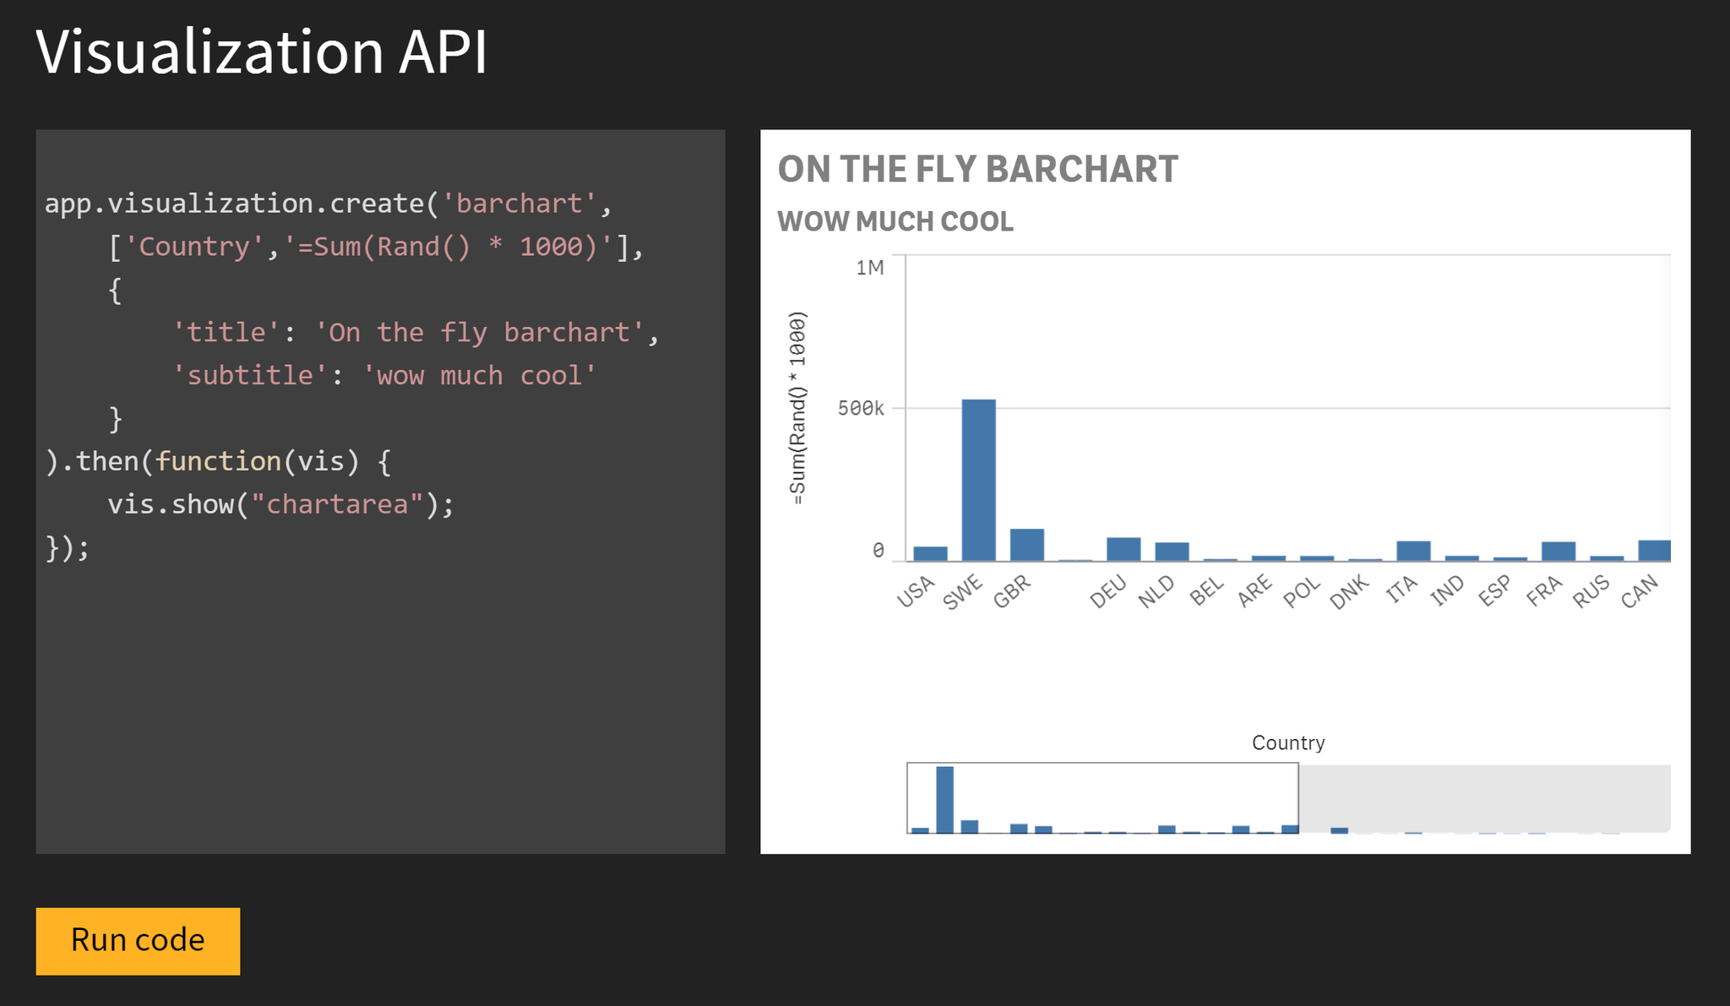

[Qlik Visuals](http://help.qlik.com/en-US/sense-developer/2.2/Subsystems/Mashups/Content/QlikVisual/mashups-create-visualizations-on-the-fly.htm)

Bar chart on the fly

Based on the Visualization API ***Qlik Visuals*** allows you to create visualization objects on the fly in a 100% declarative manner:

<qlik-visual appid="Helpdesk Management.qvf"  
 type="barchart"  
 cols='["Case Owner Group","=Avg([Case Duration Time])"]'  
 options='{"title":"On the fly barchart"}'>  
</qlik-visual>

Results into:

Machine generated alternative text:
On the fly barchart 
25 
Case Owner Group 

Pivot-table on the fly

This example creates a pivot table with two dimensions and two measures and label definitions for the measures.

<qlik-visual appid="Helpdesk Management.qvf"  
        type="pivot-table"   
        options='{"title" : "Case Owner Group Case stats per year"}'  
        cols='[  
                "Year", "Case Owner Group",   
                {  
                        "qDef" : {   
                                "qDef" : "=Avg([Case Duration Time])",   
                                "qLabel" : "Avg Case Duration Time"   
                        }  
                },  
                {  
                        "qDef" : {   
                                "qDef" : "Sum( [Open Cases] )",   
                                "qLabel" : "Open Cases" }  
                        }  
        ]' >  
</qlik-visual>

**Example code output:**

Machine generated alternative text:
Case Owner Group Case stats per year 
Year 
Case Owner Group 
Measures 
Avg Case Duration Time 
15."6934 
46.189742 
117.56781 
55.33g418 
16.914114 
53.583879 
ze.917aeg 
8.e133655 
Open Cases 
e 
e 
e 
2e1e 
IT Infrastructure 
Systems 
Systems Development 
2e11 
2e12 
826 
378 
778 
482 
162 
7845e 
168978 

From <<http://help.qlik.com/en-US/sense-developer/2.2/Subsystems/Mashups/Content/QlikVisual/mashups-create-visualizations-on-the-fly.htm>>

Qlik Analytics for Visual Studio plug-in

You can also use this [visual studio 2015 plug-in](http://help.qlik.com/en-US/sense-developer/2.2/Subsystems/Plugins/Content/GettingStarted/GettingStarted.htm) to embed Sense in your website and is available on the [Microsoft's plugin site](https://visualstudiogallery.msdn.microsoft.com/de8d2bfa-fd5e-44d5-ab23-f8bccdcc2ef0?SRC=Home). This allows you to drag and drop Qlik Sense content and the code will be generated for you. The Visual Studio plugin is a development toolbox created to simplify the process of integrating Qlik Sense functionality into other environments. Qlik Analytics for Visual Studio provides quick access to relevant information from your Qlik Sense environment, which for instance makes it easy to integrate Qlik Sense visualizations into an existing web site.

You will be able to:

* See all your apps, with related sheets and objects.
* See a preview of the object.
* See the properties of the server and charts.
* Drag-and-drop objects (in different modes) directly into your code.

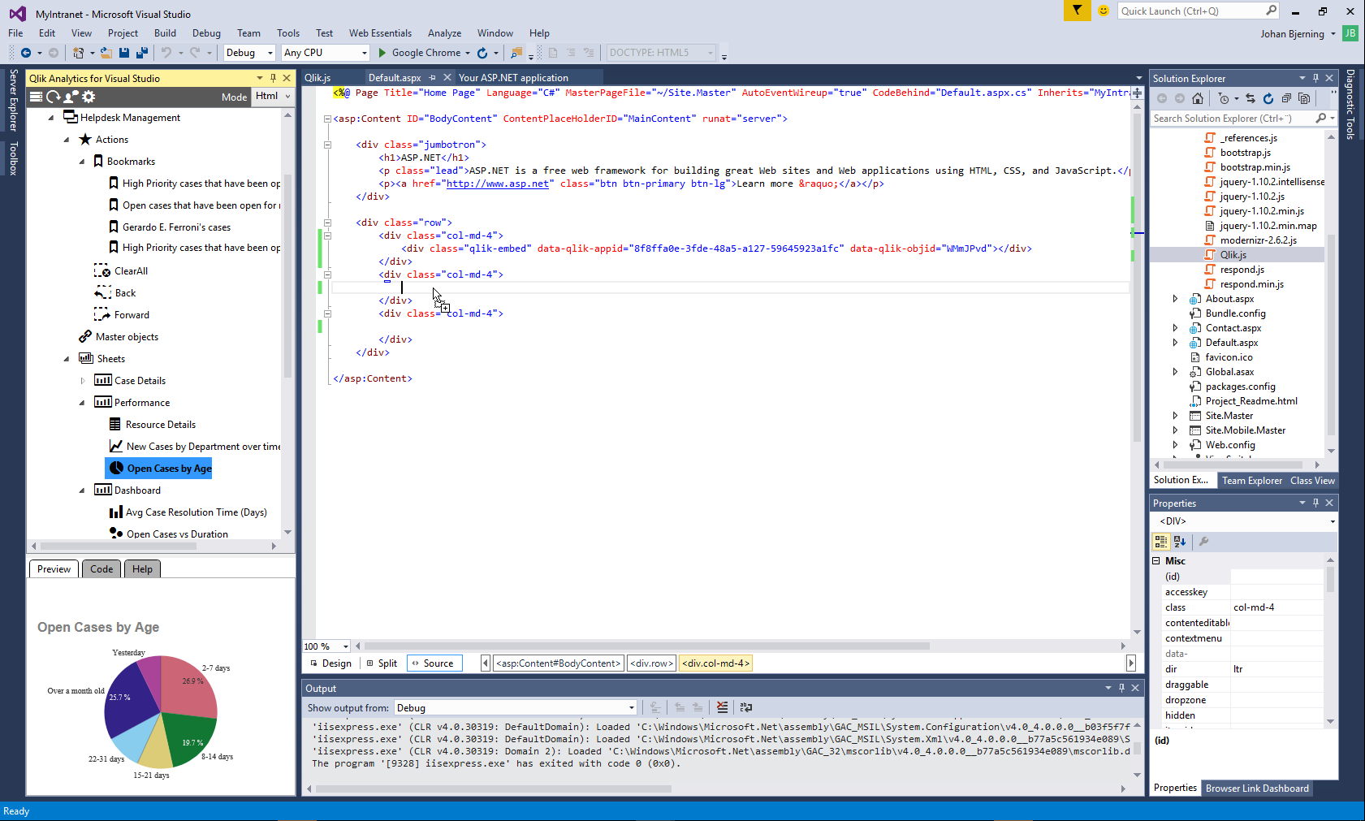

See appendix A for more info.

Mashup Examples

A great example of what the workbench or Qlik Analytics Platform can do is showcased [through our partnership with NCAA.com](http://www.qlik.com/us/company/press-room/press-releases/2015/en/0617-qliks-got-game-powers-visual-analytics-for-college-basketball-fans), where the platform was used by our own web developers to build custom embedded analytics in the [NCAA.com website](http://www.ncaa.com/2015-college-baseball-tournament-statistics) providing insight into the performance of teams in the Men’s College World Series baseball championship.

|  |
| --- |
| **Examples** |
| [Axis group](http://viz.axisgroup.com/portfolio/) |
| [Qlik web apps demo](http://webapps.qlik.com) |
| [United nations (UN)](http://diplomaticpulse.qlik.com) |
| [Mashup using tabs](http://webapps.qlik.com/tabs-template-demo/tabsTemplateDemo.html?_ga=1.90184346.1096817856.1445365428) |
| AFAS [jaarverslag](http://jaarverslag.afas.nl/2015/portal-jaarverslagartikel-2015/financiele-kerncijfers-2015) |

Get started to work with mashups

* Examples to [get started](https://help.qlik.com/en-US/sense-developer/2.2/Subsystems/Mashups/Content/Howtos/working-with-mashups.htm) with mashups.
* Sense mashup deployment [manual](https://help.qlik.com/en-US/sense-developer/2.2/Subsystems/Mashups/Content/Howtos/mashups-deploy-scenarios-mashup-normal.htm)
* Real integration examples on [JSFiddle](https://jsfiddle.net/user/mindspank/fiddles/)
* [This](http://sentienttidbits.blogspot.nl/2014/09/porting-d3js-visualisations-to-qlik.html) [example](https://github.com/mindspank/d3-capabilitiesapi/blob/master/main.js) shows you how to connect to Sense data and vizualize it using D3.
* [creating-a-website-with-angular-and-the-capabilities-api](http://creating-a-website-with-angular-and-the-capabilities-api)
* [Example](http://webofwork.com/authenticate-qlik-sense-in-an-nodejs-express-app-on-an-external-web-host/) nodejs ticket and div integration
* [Sense Utils](https://github.com/skokenes/senseUtils): Handy package to include Sense in your site (see examples from [Axis group](http://viz.axisgroup.com/portfolio/))

Extensions: the ability to create your own visualizations (charts, custom JS objects) inside an app

Welcome to 
QIik Branch 
A place to share and collaborate on open source 
projects and ignite innovation leveraging alik 
products 
Heat map 
Treemap 
• Siæ 
Extensions Examples 
Branch.qlik.com is QIik's open source community 
Insertanyjavascriptchartpu like 
Re-usable Sankey 
Bullet Bar 
D3 Library Website 
Box Plots 
Non •contiguous 
Cartogram 
Circle Packing 
Bubble Chart 
Chord Diagram 
Population Pyramid 
Node-link Tree 
Bullet Charts 
Dendrogram 
Stacked Bars 
Treemap 
Calendar View 
Force-Directed 
Stre 
Voronoi Diagram 

See this [60 second video to start](https://www.youtube.com/watch?v=-bxlwEdmaAQ).

[Extensions](https://community.qlik.com/thread/127472) are used to [extend](https://help.qlik.com/sense/2.0/en-US/developer/#../Subsystems/Extensions/Content/extensions-getting-started.htm%3FTocPath%3DBuilding%2520visualization%2520extensions%7CGetting%2520started%2520building%2520visualization%2520extensions%7C_____0) the out of the box charts in Qlik Sense based on open standards such as HTML5, JavaScript and CSS. The new objects behave the same as "out of the box charts" with full two way interaction with Qlik datamodel and selections made. They create new ways to visualize data and enhance user input and interaction. They can integrate with other systems (such as write back selected items to source database) and visual libraries such as [D3](http://blog.axc.net/tutorial-how-to-build-a-qlik-sense-extension-with-d3/), google maps, youtube and other webservices, or you can add new selection objects (sliders, input boxes).

Qlik Sense’s JavaScript APIs bring the power of Qlik Sense to web application development. It enables JavaScript developers to build data analysis and visualization applications using Qlik Sense charts. The developer can insert pre-built charts into their web page make it very fast to build applications, unlike D3 where the user has to build each visualization from scratch. Because Qlik Sense charts are linked, selections one chart automatically propagate through all charts. Qlik Sense charts and data can also be used in mashups, for example, an RSS feed address could come from a field in a Qlik Sense table – to support the building of mashups, Qlik Sense has a built-in [mashup editor](localhost:4848/dev-hub). Qlik Sense data can be used in D3 or in other JavaScript-based visualization libraries.

All of the technology will be very familiar to web developers – it’s based on JavaScript, HTML, and CSS3. For those developers interested in the deep technical javascript instructions:

The posts reference some code samples on Qlik Branch (our open source community to extend functionality of Sense using our API's) [here](https://github.com/brianwmunz/QlikSenseMashupBasicsTutorials/tree/master/code%20samples). Read the [tutorial](https://github.com/stefanwalther/qliksense-extension-tutorial) for more information.

|  |  |
| --- | --- |
| What | Where |
| [Getting started using extenions](https://help.qlik.com/en-US/sense-developer/2.2/Subsystems/Extensions/Content/extensions-getting-started.htm) | [Qlik Extensions help](https://help.qlik.com/en-US/sense-developer/2.2/Subsystems/Extensions/Content/extensions-getting-started.htm) |
| Get extensions and collaborate with other developers | [Qlik Branch](http://Branch.qlik.com) |
| Extension tutorial from R&D (S. Walther), also check his projects | [Stefan Walter's Github](https://github.com/stefanwalther/qliksense-extension-tutorial)  [sense-integration-extensions](http://www.qlikblog.at/category/qlik-sense/sense-integration-extensions/) |
| Key Qlik developer to follow: A. Karlsson | [mindspank github](https://github.com/mindspank/) |
| Need help? Please join our [Slack channel](http://qlikbranch-slack-invite.herokuapp.com/) | Slack |
| Deep dive javascript video tutorials, showing you how to connect to  Sense and get JSON data in your app, execute selections, and  automate everything | Youtube  **Part 1:** [**Getting Set Up**](https://www.youtube.com/watch?v=ffyZy7RlSoE)  **Part 2:** [**Embedding Objects**](https://www.youtube.com/watch?v=OzzsynxIUMM)  **Part 3:** [**Connecting to Fields**](https://www.youtube.com/watch?v=fqGwrGhlW-I)  **Part 4:** [**Creating HyperCubes**](https://www.youtube.com/watch?v=pDbDbkc22Ds) |
| Create your own color themes | [Qlik Branch](http://branch.qlik.com/#!/project/57f6006e4d63b245095d2347) |

Use Sense as a fast in memory database: Show Sense data/raw JSON objects in your own webserver

You can also just use the data from Qlik Sense do with it whatever you want;

* Fill list boxes or sliders
* Include Sense charts which automatically respond to selections made.
* [Video](https://drive.google.com/file/d/0BxBEVQthCb29WTVubWRBVVhzWDA/view?usp=sharing) explaining connecting to and selecting in fields inside an non Qlik Sense website.

Appendix A: DIV tag integration approach on external server

* You create a normal HTML page which you can create with "drag and drop" in our [dev-hub](http://localhost:4848/dev-hub/). Using this approach you can link the DIV to a Sense chart ID.
* You copy our requireJS, CSS and fonts to your webserver.

|  |  |
| --- | --- |
| RequireJS | C:\Program Files\Qlik\Sense\Client\assets\external\requirejs  <script src="../../resources/assets/external/requirejs/require.js"></script> |
| CSS | C:\Program Files\Qlik\Sense\Client\autogenerated  Computer  Open  ites  (top  al Certificates  tent  ub  Meteor - Copy  eWebIntegration  mloads  Local Disk (C:)  Program Files  Qik  Sense  Client  Burn  New folder  Name  qros  do-not-commit-files-to-this-folder.txt  licenses.js  product-info.js  qlik styles.css  qlikui.css  autogenerated  Date modified  9/21/2016 1:18 AM  9/21/2016 1:18 AM  9/6/2016 12:15 PM  9/6/2016 12:16 PM  9/6/2016 12:16 PM  9/6/2016 12:15 PM  9/6/2016 12:15 PM  Type  File folder  File folder  Notepad++ Docum...  JScript Script File  JScript Script File  Cascading Style She...  Cascading Style She...  Size  1 KB  478 KB  483 KB  90 KB  Include  <link rel="stylesheet" href="../../resources/autogenerated/qlik-styles.css"> |
| Fonts | Go to C:\Program Files\Qlik\Sense\Client\fonts on your Sense server.  In your external webserver create a resources/fonts directory (in your web server root) and copy the fonts |
| You include a reference to these **local** files (to prevent cross site scripting); The require.js, the css and the fonts from above. | E.g. I have put them in the server\public folder on my external web server.  GitHub senseWebIntegration public  resources fonts  Name  font.icons.html  Iui- icons.ttf  qlikview-sans.ttf  qlikview-sans- bold.ttf  qlikview-sans-bold italic.ttf  q likview-sans- italic. ttf |

1. You create a Javascript file
   1. This file contains a config object, which points to your Sense Server. This file is basically the "bridge" between your website and Sense
   2. In this javascript file you attach a DIV id to a Sense Chart ID (is being generated for you if you drag and drop), and you are done.

var config = {  
        host: "myhost.com",  
        prefix: "/",  
        port: window.location.port,  
        isSecure: true  
};  
require(["js/qlik"], function(qlik) {  
        // open the app  
        var app = qlik.openApp("c31e2aba-3b46-4b13-8b87-c5c2514dea1d", config);  
        // insert Qlik objects into the page.  
        app.getObject(document.getElementById("LB01"), "uPyZavD");

From <<https://help.qlik.com/en-US/sense-developer/2.2/Subsystems/APIs/Content/MashupAPI/qlik-interface-interface.htm>>

Machine generated alternative text:
Identify the host/port that has the 
relevant Qik data. 
Define a base URL for require to get 
a correct QIik Sense module and, if 
needed, to get the used extensions 
Get a Qik Sense js module using 
require 
Open app. 
Get objects from the app. 

From: <https://help.qlik.com/en-US/sense-developer/2.2/Subsystems/Mashups/Content/mashups-introduction.htm>

PS: note that if you create a new project in the [dev-hub](localhost:4848/dev-hub), it will generate a starting template for you with the HTML, CSS and the javascript file. This tool will also generate the object guids (id) for you.